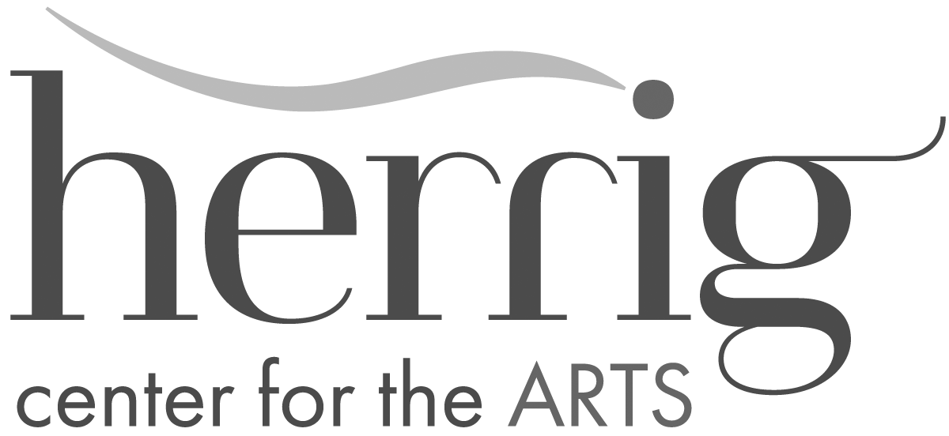

Herrig Center for the Arts Scholarship Program
Student Scholarship Application 2025

FULL AND PARTIAL SCHOLARSHIPS MAY BE AVAILABLE.
Please complete form and send to Herrig Center for the Arts

(Please Print)
Student Name: ___ Date of Birth:

Student’s School: Age:

Parent(s) or Legal Guardian(s):

Home Phone: Work Phone: Other Phone:

Email: ________________________

Street Address:

City: State: Zip Code:

Scholarship Request for which class or program:

Date of class/program: Scholarship Amount Requested:

Please explain why you are requesting a scholarship:

Parent/Guardian requesting scholarship must attach a current tax return.
(We recommend you block out all Social Security numbers.)

Family’s Estimated Total Monthly Income: $ /month

Job Title & Other Sources of Income:

Secondary Source of Income:

Do you qualify for any government programs (food stamps, Medicaid, etc.)? Yes No

Has your child(ren) received a scholarship from ArtCenter Manatee before? Yes No Unsure

Continues on next page

Who referred you to the Herrig Center for the Arts Scholarship Program?

Name Relation to Student

Personal Reference:
Name Phone Relation to Student

Signature of Parent or Guardian Date

Herrig Center for the Arts does not discriminate against any person on the basis of race, color, national origin, disability, age or sexual orientation in admission or participation in its programs, activities, or in employment.

FOR OFFICE USE ONLY:

Date received: Date Reviewed:

Scholarship was: _____ approved in the amount of: $ _________

_____ denied because________________________________________
_________________________________________________________

Date Applicant was Notified: __________________ By: __________________________

________________________________________________________________________
Signature of Herrig Center Director Date

Student Attended: _________________________________________________________

Name of Class/Program: __________________________________________________

Student Evaluation completed by: _______________________ Date: __________
Signature of Instructor

________ Evaluation Attached.

Herrig Center for the Arts
888 3rd Ave. W / Bradenton, FL 34205
941-746-2862
Herrigcenter.org
email: acm@artcentermanatee.org

