MATERIAL LIST

BIRD BLAST - WATERCOLOR W/FLUID ACRYLIC & CHEESECLOTH
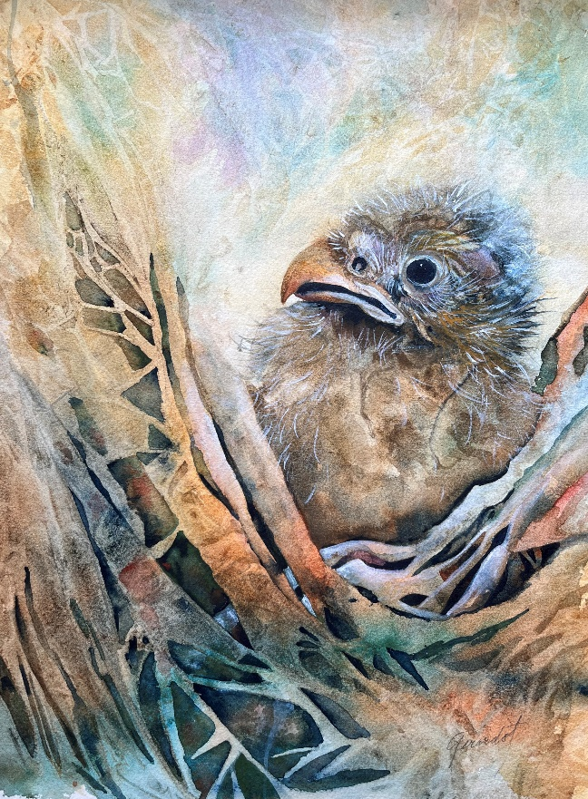
- WATERCOLORS (out of tubes
& ready to use)
- COTTON CHEESECLOTH
- SCISSORS
- SPRAY BOTTLE
- WHITE FLUID ACRYLIC
- PALETTE OR PLASTIC PLATES FOR
MIXING
- QUARTER SHEETS ARCHES
We will try to do at least (4) ptgs.
- BRUSHES (sizes 4-8 round, 1”flat,
Plus a rigor or “1” for feathers)
- TABLECLOTH
- SALTS
- SERAN WRAP
- TOOTHBRUSH
- LINE DRAWING OF HEADS
- HAIR DRYER “ BABY FALCON “
- WATER CONTAINERS

