Donna Carrion, Instructor
Beginning Jewelry Foundation
Tuesdays either 12-4pm or 6-9pm

Thank you for enrolling in ArtCenter Manatee’s jewelry program.

***Please have the items below with you for the first day of class!***

For safety, only closed toe shoes are permitted in this class. You will not be able to use the soldering stations without wearing them. Consider leaving a pair of sneakers or shoes in your car if needed.

Also anyone with long hair will have to secure it in a hair clip.

Bring a good quality dust particle mask

Ear plugs & Safety glasses or goggles

Magnifying eyeglasses****** Readers will work. If you wear eyeglasses look for either magni-clips or an opti-visor online. That is what I use. You will need to see very fine details from 8” away.

Apron

Soft and Absorbent Hand towel

Standard Notebook and /or sketchbook

Pencil & pen

Gardening Gloves (Home Depot) Please make sure they fit snuggly.

3/8” x 3/8” x 48” Basswood Round dowel (Home Depot sku# 145923 (we will use 36”)

Sharpie® Permanent Ultra-Fine Point Markers, Black (very important) (Available at any office supply, pharmacy, most large chain grocery stores.)

Several small “individual” containers with tightly fitting lids. Pill planners will not work unfortunately.

Wet / Dry Sandpaper 9 in. x 11 in. (4-Pack) Home Depot Look in the Paint Department

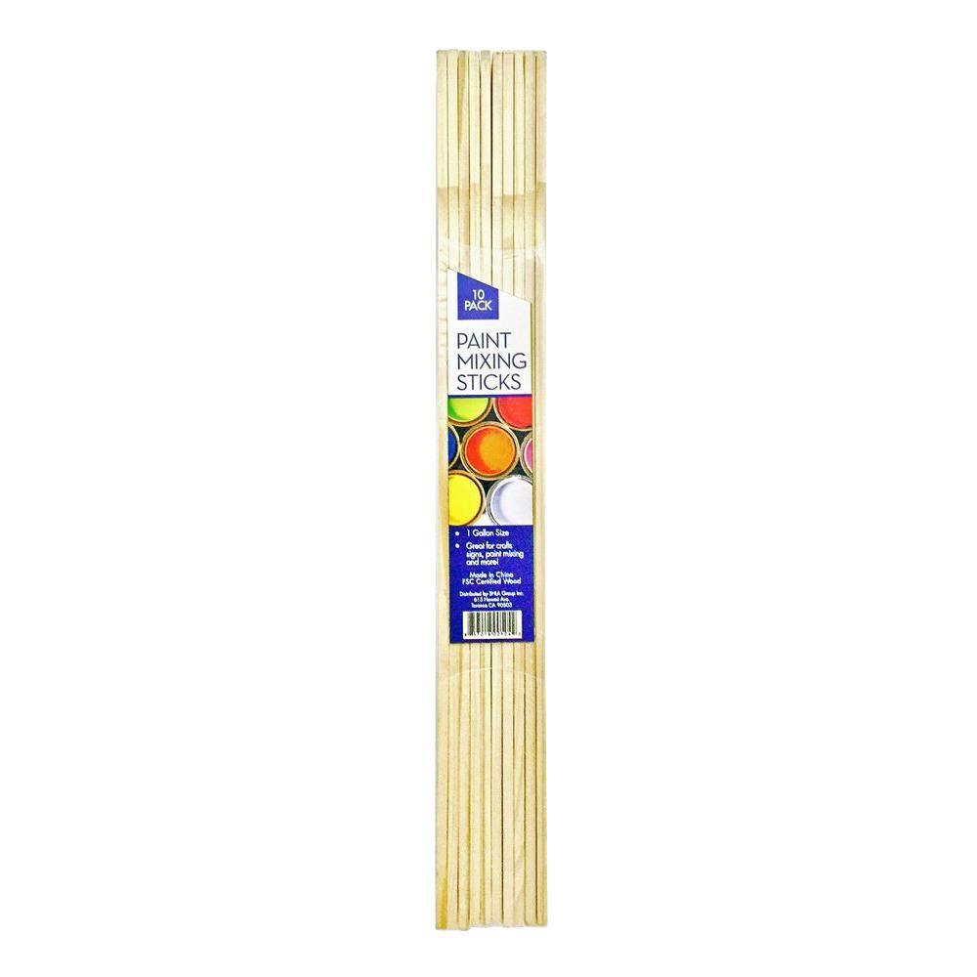
In the following Grits 220, 320, 400 Grit

1 Gal. Paint Mixing Craft Sticks (10 Pack) (Home Depot: Store SKU # 1001467943). They are in the paint department. You will need only 3 sticks.

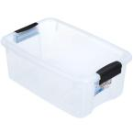
Please bring a container that can hold the items that you are bringing to class. A canvas bag and a plastic box (6” long or larger) would be great. One similar to the image would be great. Sterlite 18-Qt. Latch Storage Box with a LID from Home Depot in Store SKU #1000030691

If you already have hand tools such as pliers with smooth jaws, small wire cutters, a jeweler’s saw frame, jeweler’s saw blades and files please bring them. Otherwise a toolbox will be available for you to borrow during your class and it will be returned at the end of each class.

Metal for jewelry making, solder and saw blades will be purchased at the beginning of class.

Bring a checkbook if you are in the evening 6-9pm class so that you can pay for your supplies. Credit cards are “only” accepted during the day because the cashier in the gallery leaves at 5:45pm. If you decide to bring cash the instructor does not have access to any change.
I look forward to having you in class. See you in class.

