Donna Carrion, Instructor
Beginning Foundation for Jewelers
Tuesdays either 12-4pm or 6-9pm

Thank you for enrolling in Art Center Manatee’s jewelry program.

For safety, only closed toe shoes are permitted in this class as you will not be able to solder without the proper footwear. Also anyone with long hair will have to secure it in a hair clip.

***Please have these items with you for the first day of class!***

Bring a good quality dust particle mask

Ear plugs

Safety goggles (especially if you do not already wear glasses)

Magnifying eyeglasses****** Readers will work. If you wear eyeglasses we can discuss your options during class.

Apron

Soft and Absorbent Hand towel (Dollar Tree)

Standard Notebook and /or sketchbook

Pencil & pen

Sharpie® Permanent Ultra-Fine Point Markers, Black (very important) (Available at any office supply, pharmacy, most large chain grocery stores.)

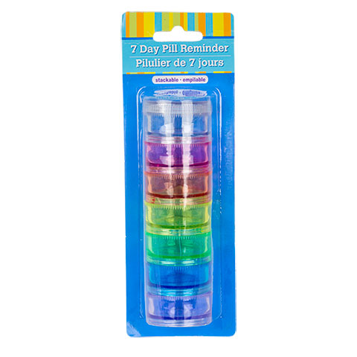

7 Day Pill Reminder (Dollar Tree SKU# 170133) or 5 to 7 small containers (about 1” or larger) with individual lids.

Gardening Gloves “Hestra” (Home Depot: Store SKU #72340-270-07 or similar) Look for a stretchy glove with palms that have gripping action. Please make sure they fit snuggly.

3M Pro Grade Precision 9 in. x 11 in. 220 Grit Fine Advanced Sanding Sheets (4-Pack) (Home Depot: Store SKU #26220PGP-4)

3M Pro Grade Precision 9 in. x 11 in. 320 Grit X-Fine Advanced Sanding Sheets (4-Pack) (Home Depot: Store SKU #26320PGP-4)

Sheets (4-Pack) (Home Depot: Store SKU #26400PGP-4) 3M Pro Grade Precision 9 in. x 11 in. 400 Grit X-Fine Advanced Sanding

36 in. Old Time Wooden Yardstick (we will be cutting it into (3) 12”pieces) (Home Depot: Store SKU #611269 or SKU # 1001467943 near the paint mixing counter)

3/8 in. x 36 in. “Waddell” Round Birch Wooden Dowel (Home Depot: Store SKU #6606U) (we will be cutting it into (3) 12”pieces)

A toolbox will be available for you to borrow during your class. It will be returned at the end of each class. If you already have jewelers pliers (with smooth jaws), a jeweler’s saw frame, saw blades (2/0 or 1/0), jewelry files please feel free to bring them.

Metal for jewelry making, solder and saw blades can be purchased at the beginning of class as needed.
Bring a checkbook if you are in the evening 6-9pm class so that you can pay for your supplies. The gallery will be closed and the instructor will not be able to supply change. You can also use the ATM at the bank across the street.

I look forward to having you in class.

