Jewelry: Volume and Texture with Donna Carrion
Sat Mar 23 & Sun Mar 24 Sat &Sun 10am – 4pm
Supply List page 1 of 3
Large hand, file Half Round
Needle files
Sand paper and Sanding Sticks: 220, 320 and 400 grit
Polishing Pads: Rio Grande Item 337398 $9.95
Polishing Gloves
Dust Mask & Safety Goggles
Bending Pliers: Stepped, Round Nose, Flat Nose, Chain Nose (if you have them)
To texture bring in any Texturing hammers, punches or chasing tools that you have.
Gemstones: 2 to 6mm with bezels or stone settings to add to your design.
Choose any of the following: sterling silver, argentium, copper, bronze or NuGold a.k.a. jeweler’s brass).
I would recommend working in two different metals so you can note the difference in working with them.
Two 2 ¼” Discs: 22g sheet / If you cut them out prior to this workshop it would be ideal. (We have a 2 ¼” disc cutter. If you are currently enrolled in one of my classes you can cut them out prior to the workshop. This tool is not available during open studio.)
Bail material: 22g sheet 1.5” by ½” (if you prefer wire please use it)
Some scrap metal to test your punches on.

Jewelry: Volume and Texture with Donna Carrion
Sat May 19th & Sun May 20 10am – 4pm
Supply List page 2 of 3
Optional: Padded Gloves / They are useful when hammering and sanding.
Harbor Freight Item 62424 Padded Mechanic’s Gloves $9.99
They frequently have this in the stores. Look for a 20% off coupon in their ads. 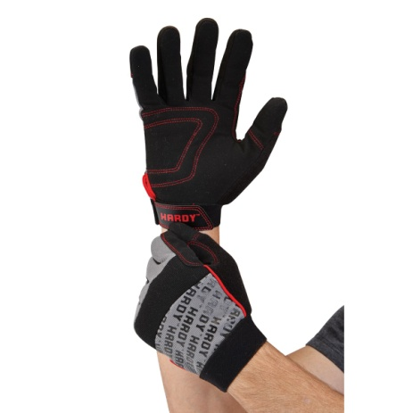

Not required but necessary. Please note that we have only two sets in our studio.
Harbor Freight Item 93539 25 Pc Doming Block and Punch Set $47.99
They frequently have this in the stores. Look for a 20% off coupon in their ads.
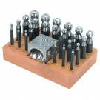

Jewelry: Volume and Texture with Donna Carrion
Sat May 19th & Sun May 20 10am – 4pm
Supply List page 3 of 3
Not required but very necessary. Please note that we have two in our studio. First come, first serve.
Rio Grande Item 112502 Sandbag (Dimensions: 37mmH x 6" dia. / Material: Leather / Weight: 2.3 lbs (1.043kg) $17.99
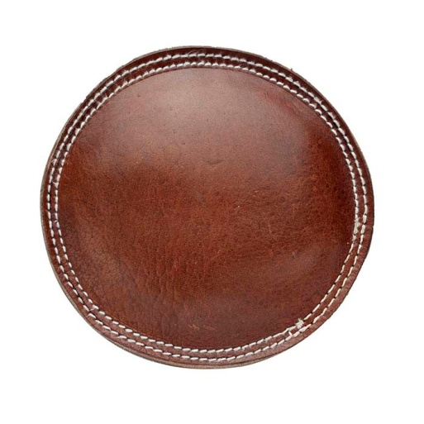

For safety, only closed toe shoes are permitted in this class.

There will be a ½ lunch break during class. You can bring your lunch or purchase it locally. Please note that some local restaurants maybe closed on Sunday.

Please arrive to class 10 minutes prior to the beginning of class. Class will begin promptly at 10 am.

